REQUIREMENT ANALYSIS PHASE

Project Title: Auto Ticket Classification using Flow Designer

1. Introduction

The Requirement Analysis Phase identifies the functional and non-functional requirements needed to develop the Auto Ticket Classification system using ServiceNow Flow Designer.

The main requirement is to automatically classify a newly created support ticket based on its ticket information. The system should read the ticket details, compare them with predefined conditions or keywords, identify the appropriate category, update the ticket, and route it to the relevant assignment group.

2. Functional Requirements

The system shall provide the following functional requirements:

• The system shall allow a user or process to create a new support ticket.

• The system shall automatically trigger the Flow Designer workflow when a new ticket is created.

• The system shall read the required ticket information such as Short Description and Description.

• The system shall check the ticket information against predefined classification rules.

• The system shall identify the appropriate ticket category based on matching conditions or keywords.

• The system shall update the ticket record with the identified category.

• The system shall assign the classified ticket to the appropriate assignment group.

• The system shall preserve the ticket information after processing.

• The system shall provide a default or manual-review path when no classification rule matches.

3. Non-Functional Requirements

The system should satisfy the following non-functional requirements:

• The workflow should be simple and easy to maintain.

• The classification rules should be easy to modify.

• The system should process tickets consistently.

• The workflow should reduce unnecessary manual steps.

• The system should provide reliable ticket classification.

• The design should use standard ServiceNow Flow Designer capabilities where possible.

• The workflow should be easy to test and update.

4. Input Requirements

The system requires the following input information:

• New support ticket

• Short Description

• Detailed Description

• Existing ticket fields

• Ticket-related information required for classification

5. Processing Requirements

The system shall process the ticket using the following sequence:

1. Receive a new support ticket.

2. Trigger the Flow Designer workflow.

3. Read the ticket information.

4. Check the ticket information against predefined conditions or keywords.

5. Identify the appropriate category.

6. Update the ticket record.

7. Select the appropriate assignment group.

8. Route the ticket to the selected assignment group.

9. Classification Requirements

The system should support classification of common ticket types such as:

• Hardware – Laptop, keyboard, mouse, printer-related issues.

• Software – Application, software, and installation-related issues.

• Network – Wi-Fi, internet, network, and connection-related issues.

• Access – Login, password, account, and access-related issues.

• Default / Review – Used when no predefined classification rule matches.

7. Assignment Requirements

After classification, the system should route the ticket to the appropriate assignment group.

Example:

Hardware Issue → Hardware Team

Software Issue → Software Team

Network Issue → Network Team

Access Issue → Access Support Team

No Matching Rule → Default / Manual Review

8. Error and Exception Requirements

The system should handle exceptions during ticket processing.

• If required ticket information is missing, the system should avoid applying an incorrect classification.

• If no classification rule matches, the ticket should be assigned to a default category or sent for manual review.

• If the ticket update action fails, the ticket should remain available for manual processing.

• Classification rules should be tested using different types of ticket descriptions before deployment.

9. Requirement Analysis Flowchart

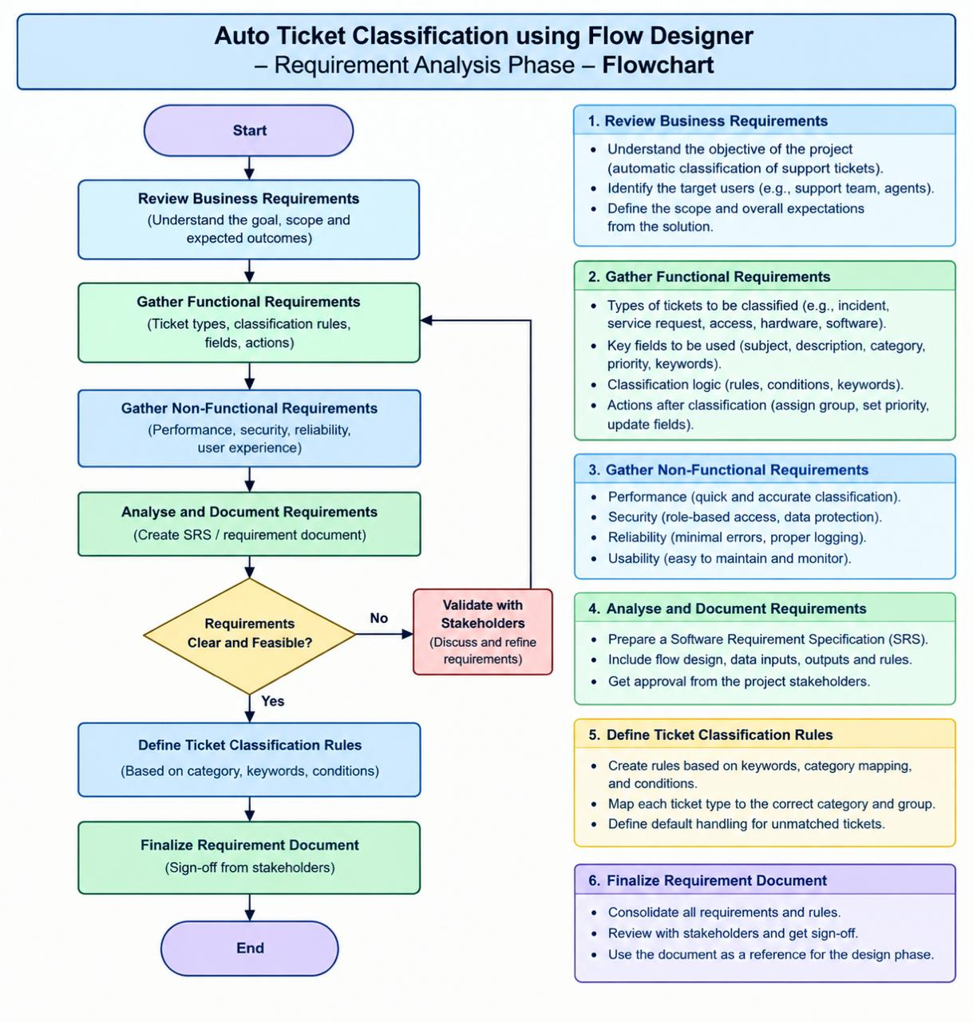

10. User Requirements

The user should be able to:

• Create a support ticket.

• Enter the required ticket information.

• View the updated ticket category.

• View the assigned assignment group.

• Review tickets that are not automatically classified.

11.System Requirements

The system requires:

• ServiceNow Platform

• Flow Designer

• Incident / Ticket Management

• ServiceNow Tables and Records

• Web Browser

12. Expected Output

After processing, the system should produce a classified ticket with:

• Appropriate ticket category

• Updated ticket information

• Selected assignment group

• Updated routing information

If no matching rule is found, the ticket should follow the default or manual-review process.

13. Requirement Summary

The requirement analysis establishes the necessary functional, non-functional, input, processing, classification, assignment, and exception requirements for the Auto Ticket Classification system.

The requirements provide a clear foundation for designing and implementing the Flow Designer workflow in ServiceNow.

